Welcome!
Date
Name
Spouse
Address
City
State Zip _________
Email

Please Contact By
❑ Card  Phone  Visit

Telephone Best Time to Call
Home ______________
Work ______________

Guest: First Time Second Time
Are you a church member: yes no
Church
City, State

Circle Appropriate Age/Grade Group(s)
Preschool: Ages: B-1 2-3 4-5
Children: Grades: K 1 2 3 4 5 6
Youth: Grades: 7 8 9 10 11 12
Adults: Ages:18-29 30s 40s 50s 60s+

How did you learn about our church?
Newspaper Friend Yellow Pages Mail
Other

I am a guest of:

New in the Community? Yes No
Names & ages of children at home

Weekly Service & Activity Schedule

April 1, 2018
9:45 a.m. Sunday School
11:00 a.m. Worship Service
No Evening Service

Week of April 1, 2018
Wednesday 6:30 pm……………..……….Meal/Bible Study
Friday 6:30 pm……………….…………..Men’s 42 Night

April
8…………………………..…..New Commandment Kids
8………………………………….………….Lord’s Supper
8…………………………………………Business Meeting


April Stuffed Animals
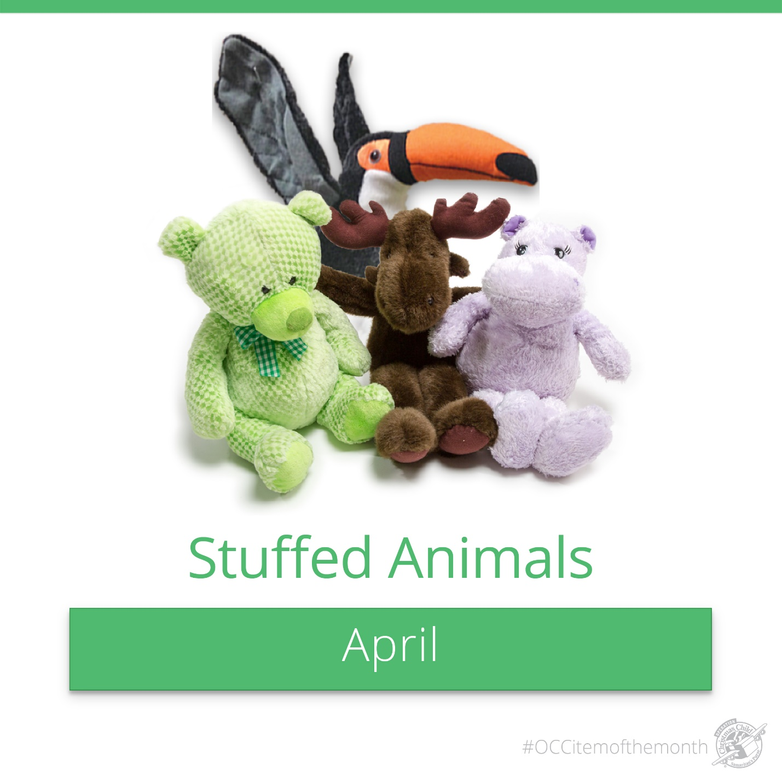
Remember, the animals have to be small enough to fit in a shoebox with other items. There is a box in the foyer for the items and a shoebox for monetary donations
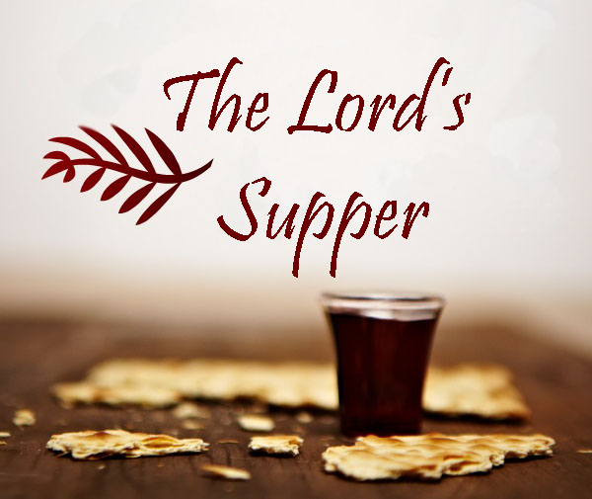
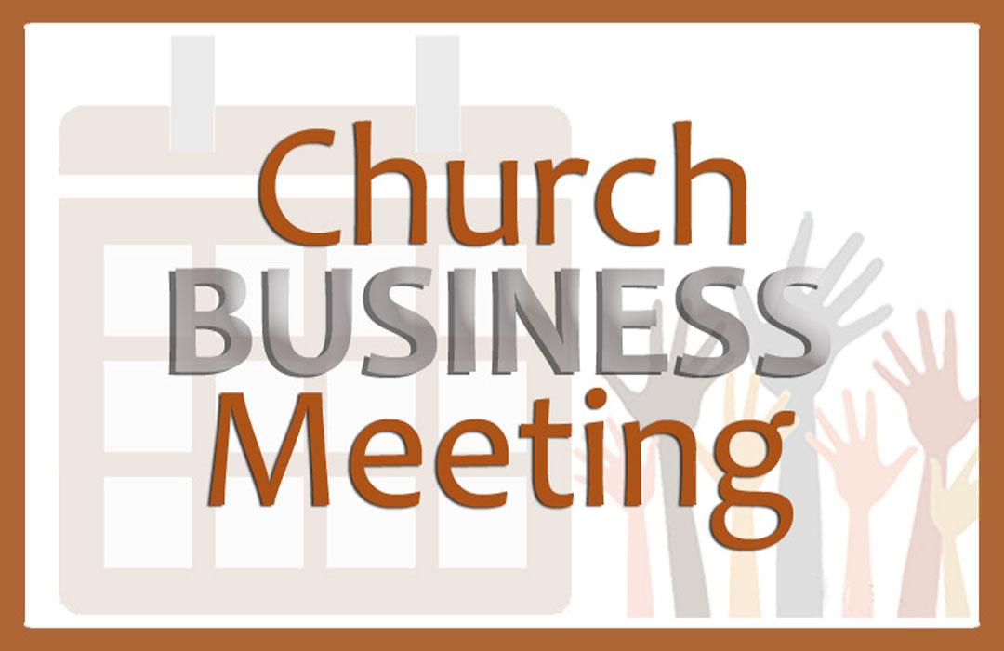
Sunday Apr 8

Sunday Apr.8 during the worship service

After evening service

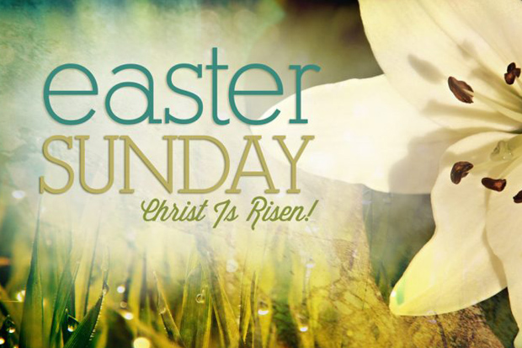

Knobbs Springs Baptist Church

April 1, 2018

Church Information:

KnobbsSpringsBC.com KnobbsSpringsBaptist@gmail.com

1662 CR 305, McDade, Texas 78650 512-273-2743

David Atwood, Pastor Cell 512-470-5098

Patti Radford, Office Manager Cell 512-968-7821

